|  |
| --- |
|  |
| Rainbow Machine Vision Grading |
|  |
| Functional Specification |

**AliceWell**

January 25, 2013

Authored by: Jackie Tran

Rainbow Machine Vision Grading

Functional Specification

# INTRODUCTION

Rainbow is a system of IP camera, PC based image processing software and communication network which designed to optically grade wooden knot. The system then interfaces and provides knots coordination to controller PLC for processing.

# NETWORK SETUP

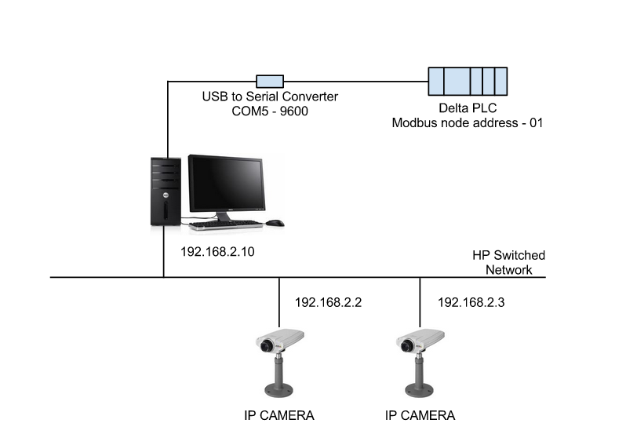

Figure 1: Network configuration

The communication between IP camera and Application PC is through HP Ethernet Switch. Please refer to Figure 1 for the network configuration and addressing. The IP network is on the local 192.168.2.0/255.255.255.0 class C network. IP camera can be managed through the internet web server at the designated IP address.

The vision software is a Windows 7 based application which processes the images taken from the IP camera at the rate of 30 frames per second. The knots radius and coordination are extracted from the received images. It then sent to PLC for control through Modbus network. The Modbus is based on USB to serial converter, with the COM5 virtual port.

# ADDRESS MAPPING

The detected knots radius and coordination are sent to PLC to the D600 range registers. Please refer to Table 1 for detail description:

|  |  |  |  |
| --- | --- | --- | --- |
| **PLC Address** | **Description** | **Knot ID** | **Camera** |
| D600 | Radius | 1 | 192.168.2.2 |
| D602 | X Coordination |
| D604 | Y Coordination |
| D606 | Radius | 2 |
| D608 | X Coordination |
| D610 | Y Coordination |
| D612 | Radius | 3 |
| D614 | X Coordination |
| D616 | Y Coordination |
| D618 | Radius | 4 |
| D620 | X Coordination |
| D622 | Y Coordination |
| D624 | Radius | 5 |
| D626 | X Coordination |
| D628 | Y Coordination |
| D630 | Radius | 1 | 192.168.2.3 |
| D632 | X Coordination |
| D634 | Y Coordination |
| D636 | Radius | 2 |
| D638 | X Coordination |
| D640 | Y Coordination |
| D642 | Radius | 3 |
| D644 | X Coordination |
| D646 | Y Coordination |
| D648 | Radius | 4 |
| D650 | X Coordination |
| D652 | Y Coordination |
| D654 | Radius | 5 |
| D656 | X Coordination |
| D658 | Y Coordination |

Table 1: Modbus Address Map

The result is updated from application PC to PLC every 500ms.